Final Testing Documentation
21Spr07-CWC3DGen Team
Luis Castaneda, Skyler Penny, Lucas Sottile, Simon Stoner

Implementation Plan:
The final prototype generator design testing procedure is outlined throughout this report. The primary goal of testing the generator is to measure the performance characteristics to compare with the engineering requirement parameters for the project. The generator prototype has been tested and refined for this final testing process both using simulation and trials with multiple iterations. Testing is conducted for both open circuit results and loaded circuit results to determine the generator output values. The testing procedure will enable the engineering requirements formulated for this project in table 1 to be investigated for the final iteration design. Table 1 outlines the nine engineering requirements on the left and their associated target values and range in the right column. Each target value must be investigated through the testing procedures to ensure that the final design meets the capstone project specifications. Working through each engineering requirement is the most logical approach to ensure that all aspects of the generator model are in line with the table 1 target values. The implemented testing procedures and measured data are detailed throughout the body followed by the results. Each section defines parameters and the testing procedures used to show that the final product meets the necessary values.
Table 1: Engineering Requirements
ER | Target Units
1. Reliability | (10^6 Revolutions)
2. Durability | (>6000 RPM)
3. Voltage | (<=48 Volts)
4. Peak Power | (200-400 Watts)
5. Power Rating | (125-240 RPM/Volt)
6. Total Cost | (<$500)
7. Weight | (<1000 grams)
8. Current | (~2.89 Amps)
9. Resistance | (166 Ohms)

- KV Rating and Voltage
Initially, the first portion of testing is conducted with an open circuit to find the KV rating for the generator model. Testing this project parameter includes running the generator model at varying speeds while measuring the phase-to-phase voltage. This test could also help passively determine the reliability and durability parameters while operating the generator at differing speeds for a prolonged period. Implementation of this test required running the generator at incremental angular velocity values from low to high RPM. To conduct this test, a dynamometer powered by a DC power regulator bank was used. The dynamometer is connected to the generator model using a coupling. The generator model itself is positioned horizontally using the stand built for displaying the device. Figure 1 below shows the front of the dynamometer connected with the coupling to the generator. The generator stand is duct-taped to the table to stop any vibration or movement from occurring during the testing operation.
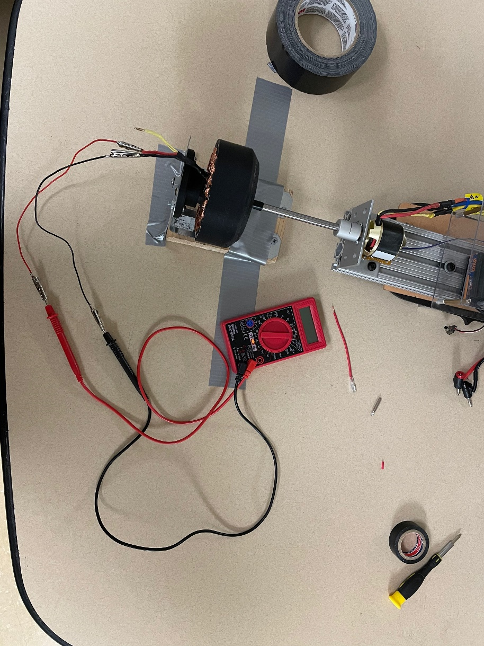
Figure 1: Open Circuit Testing
A multimeter is shown in figure 1 which was used to measure the phase voltage with two connectors with alligator clips. The multimeter was used to test and record the voltage of each phase while the dynamometer rotated the rotor at four increasing RPM values. During open circuit testing, a polycarbonate shield covered the generator to reduce the chances of injury if a failure occurred. Table 2 below contains the data collected during the open circuit testing. The first column shows each RPM that the dynamometer was set to when the voltage was measured from each phase. The total voltage average across the three phases for each speed is calculated.
Table 2: Open Circuit Phase Voltage Data
RPM | Phase A (V) | Phase B (V) | Phase C (V) | Total (V)
960 | 4.6 | 4.4 | 4.5 | 7.794228634
2160 | 11.1 | 10.6 | 10.9 | 18.8793538
3072 | 19.3 | 18.3 | 18.3 | 31.69652978
4060 | 22.8 | 21.5 | 22.1 | 38.27832285

During the open circuit testing operation, the generator was held at the RPM values shown in table 2 for 30-60 seconds. This allowed enough time for the multimeter to read the phase-to-phase AC voltage across all three banana plugs shown in figure 1. The phase A voltage was found by measuring from A to B. The second phase B voltage is found by measuring from B to C and the third C voltage from A to C. The notation for each phase is only to allow the team to keep track during testing, the color of the plugs distinguishes between the three phases of the generator. The total voltage is calculated using the wye connection phase to phase vector diagram in figure 2 below.
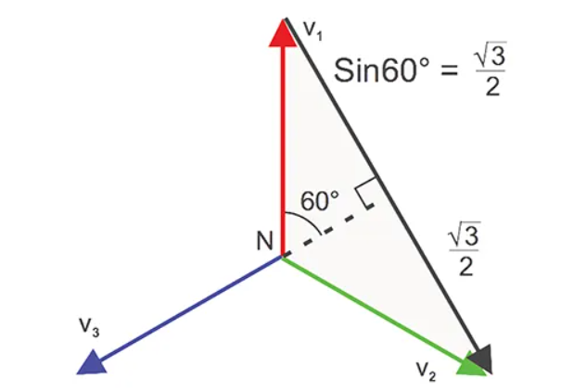
Figure 2: Wye Three Phase Voltage Vector Diagram [1]
Utilizing the principles of the three-phase wye configuration voltage diagram of figure 2, the total voltage across each of the 120° phases is found using equation 1 below [1].
$$\begin{aligned}V_{total }= \sqrt{3}*V_{phase neutral}\#1\end{aligned}$$
The resulting AC voltage across all three phases at each RPM value is shown in the right-most column of Table 2 above. Using the collected data, a graph was produced to show the resulting data trend between the output voltage for each RPM value. Figure 3 shows the resulting data plotted to visualize the output performance characteristic of the generator model.

Figure 3: RPM vs. Voltage Open Circuit
The open-circuit testing procedure results allowed the team to compare the generator performance to the voltage, KV rating, and durability parameters in table 1. The maximum voltage during this testing procedure did not exceed the 48-volt limit as shown by the resulting data in figure 3, peaking out at 38.3 volts at 4060 RPM during testing. Furthermore, the KV rating was computed for each speed during the test, and a total average KV rating is shown in table 3 below.
Table 3: Average KV Rating
RPM | KV Rating (RPM/V)
960 | 123.2
2160 | 114.4
3072 | 96.9
4060 | 106.1
Average KV | 110.1

The KV rating of 110 is just below the range of 125-240 (RPM/V) in the engineering requirements table 1. This result could still be deemed acceptable as it lies just outside of the initial requirements and is on the lower end of the range. Achieving a lower KV is more desirable than a higher one because it proves the generator does create enough voltage output at lower operating speeds.

- Peak Power, Resistance, and Current (Loaded Circuit Testing Section)
The load test consists in applying a load to the main generator to measure electrical factors such as DC voltage, DC, and angular velocity. The purpose of this test is to determine the power output. This test was performed converting AC to DC from the generator output using a three-phase rectifier bridge in which the positive and negative terminals were connected to a load. Figure 4 shows a schematic of the setup. This test was performed multiple times with a different load value that ranges from 12.6 ohms to 7.65 K-ohms. The tables with measurements and calculations are done can be seen in appendix 1. Voltage and current were measured as seen in Figures 6 and 7 respectively. With these results power was calculated using equation 2.
$P=IV$(2)
A relationship between load value and power was found from the results. It was found that the bigger a load and velocity value was, the bigger the power consumption. Therefore, the results follow the power equation in which power is proportional to resistance. This can be seen in figure 5.
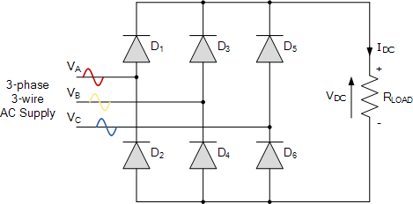
Figure 4: AC Supply Connected to the Rectifier Schematic [2]

Figure 5: Power vs RPM graph
As per figure 5 and tables in appendix A, the generator was unable to meet the required power and current output. However, the generator was able to perform well under and above the resistance of 166 ohms without overheating itself or the resistor in place. Thus, meeting the engineering requirement.

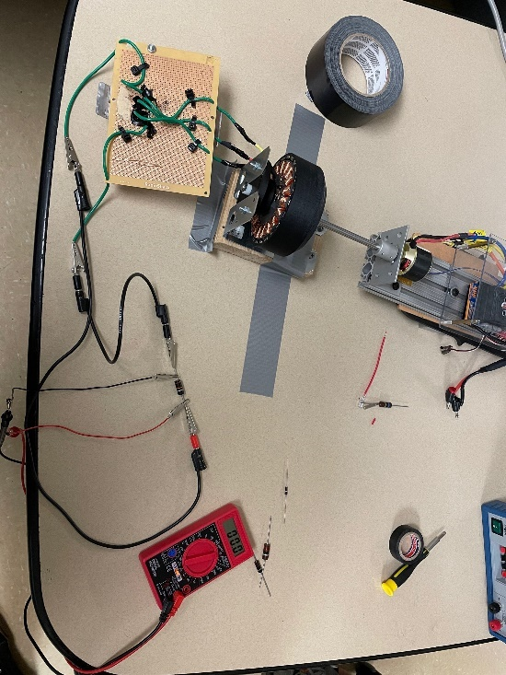
Figure 6: Measuring voltage set up
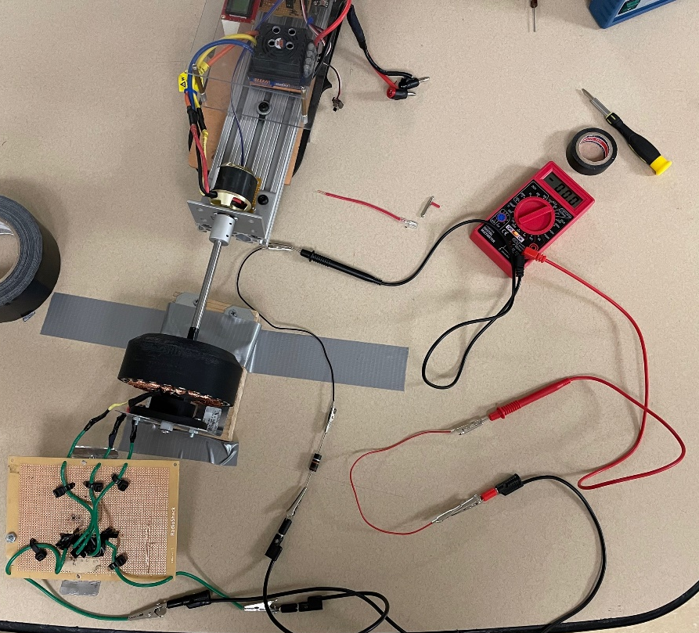
Figure 7: Measuring current set up

- Weight
The Weight of the motor was calculated by summing the mass of each component of the motor. The rotor has a mass of 111g, the magnets weigh 3.4g*24 magnets, the stator has a mass of 177g, and 55g for the backplate. The shaft weighs 79g, around 159g for the windings, and finally the bearings, E-clip, and nylon washer about 10g. This leads to a total mass of 672.6 grams which meets the team’s requirement of having a mass under 1000 grams or 1 Kilogram.
4. Cost
The estimated cost for each component of the final iteration generator can be seen below in Table 4. The cost for the final iteration generator is approximately $95.06 with the stator and magnets contributing to most of the cost at $12.43 and $42.86 respectively. The $500 engineering requirement is the total budget for all generator iterations and includes the 3 previous generator iterations from semester 1 and early semester 2. Accounting for all purchases, $320.01 has been spent leaving our final budget at $179.99 which is well under the overall budget. Judging the engineering requirement solely on the components and material used for the final iteration, the cost accounts for roughly 19% of the overall required budget of $500, and the total cost for all iterations based on the purchases made accounts for 64% of the overall budget.

Table 4: Bill of Materials
ITEM NO. | COMPPONENT | DESCRIPTION | QTY | COST
1 | ROTOR | ABS PLASTIC 3D PRINTED ROTOR | 1 | $11.70
2 | BEARINGS | 8MM BALL BEARINGS | 2 | $8.74
3 | MAGNETS | NEODYMIUM N-52 MAGNETS | 24 | $42.86
4 | STATOR | MAGNETIC IRON-BORE 3D PRINTED PLA | 1 | $12.43
5 | BACKPLATE | ABS 3D PRINTED ABS | 1 | $5.85
6 | BUSHING | 8MM NYLON BUSHING | 1 | $1.75
7 | E-CLIP | 5/16” E-CLIP RETAINING RING | 1 | $0.33
8 | 8MM SHAFT | 1055 CARBON STEEL 8MM SHAFT | 1 | $7.00
9 | COPPER COILS | AWG 24 GAUGE COPPER WIRE | 1 | $4.40

6. Durability
Two MR128ZZ deep groove ball bearings were used in the assembly of the final iteration generator. Our team felt it best to approximate the bearing life in revolutions based on the Timken Deep-Groove Ball Bearing catalog which gives a rated life of 1million cycles for ball bearings [4]. The life in hours is dependent on the radial force applied to the bearing via the shaft. Since the radial force to the shaft is minimal, it is expected that the bearings will have an expected life in hours past 100 hours which gave our team optimal time to test and perform the necessary applications. Based on the type of bearing used for assembly, our generator meets the engineering requirement of 10^6 (1million cycles).

6. Reliability
Based on the MISUMI catalog for ball bearings, the MR128ZZ bearings can withstand a max speed of 40,000 RPM using grease as the main lubricant [4]. The max speed is well over the engineering requirement of 6,000 RPM, however, our team thought it best not to run the generator no more than 10 seconds at the required speed to prevent other components (i.e., magnets, backplate) from coming loose. Our generator will perform at lower speeds at around 3,000-4250RPM for nearly 5 mins before a loss in voltage, indicating more heat-driven through the copper coils from the generator core.

Table 5: MISUMI MR128ZZ Bearing Catalog
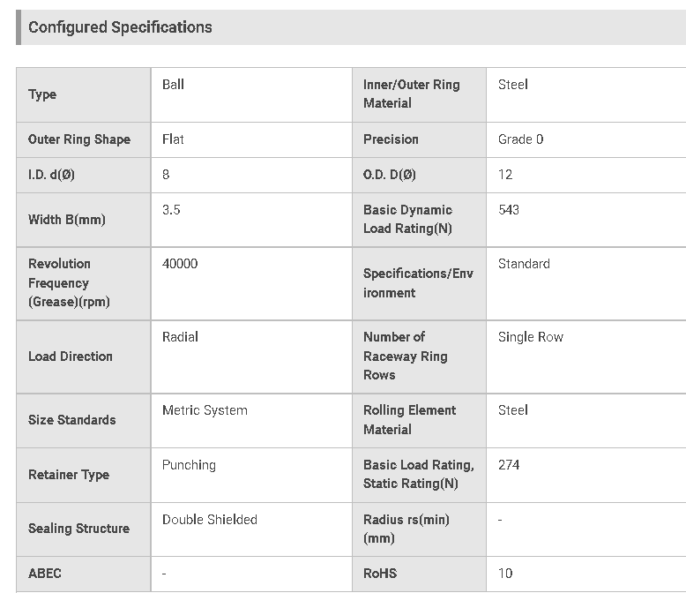

References
[1]: E. Csanyi, “Basic three-phase power measurements explained,” Basic Three-Phase Power Measurements Explained , 04-Nov-2021. [Online]. Available: https://iaeimagazine.org/electrical-fundamentals/basic-three-phase-power-measurements-explained/. [Accessed: 02-Dec-2021].
[2] AspenCore, "Electronics Tutorials," 2020. [Online]. Available: https://www.electronics-tutorials.ws/power/three-phase-rectification.html#:~:text=Full-wave%20Three-phase%20Rectification%20The%20full-wave%20three-phase%20uncontrolled%20bridge,is%20obtained%20by%20using%20two%20half-wave%20rectifier%20circuits.. [Accessed 02 December 2021].

[3] “Timken Deep Groove Ball Bearing Catalog 10857.” [Online]. Available: https://www.timken.com/resources/10857_deep-groove-ball-brgs-catalog/. [Accessed: 02-Dec-2021].
[4] “Misumi Home,” MISUMI. [Online]. Available: https://us.misumi-ec.com/vona2/detail/221000528976/?HissuCode=MR128ZZ&gclid=Cj0KCQiA-qGNBhD3ARIsAO_o7ykhKDQHfX_YvPaW36tYYmEvODnxKkGiYWvrtpQ7iS4pN7emmoy-NncaAkotEALw_wcB. [Accessed: 02-Dec-2021].

Appendix
Table 6: Load Test One, at 7.65k Ω
 | RPM | DCV | DCC | Power | Resistance Ω
1 | 420 | 0.05 | 5.90E-06 | 2.95E-07 | 7.65k
2 | 1200 | 0.11 | 1.45E-05 | 1.60E-06 | 7.65k
3 | 1560 | 0.15 | 1.95E-05 | 2.93E-06 | 7.65k
4 | 2040 | 0.21 | 2.73E-05 | 5.73E-06 | 7.65k
5 | 2525 | 0.26 | 3.40E-05 | 8.84E-06 | 7.65k
6 | 3000 | 0.33 | 4.35E-05 | 1.44E-05 | 7.65k
7 | 3600 | 0.43 | 5.62E-05 | 2.42E-05 | 7.65k

Table 7: Load Test Two, at 36.5 Ω
 | RPM | DCV | DCC | Power | Resistance Ω
1 | 420 | 4.0E-04 | 8.90E-06 | 3.56E-09 | 36.5
2 | 1200 | 7.0E-04 | 1.67E-05 | 1.17E-08 | 36.5
3 | 1560 | 9.0E-04 | 2.18E-05 | 1.96E-08 | 36.5
4 | 2040 | 1.1E-03 | 3.05E-05 | 3.36E-08 | 36.5
5 | 2525 | 1.4E-03 | 3.81E-05 | 5.33E-08 | 36.5
6 | 3000 | 1.8E-03 | 5.00E-05 | 9.00E-08 | 36.5
7 | 3600 | 2.3E-03 | 6.33E-05 | 1.46E-07 | 36.5

Table 8: Load Test Three, at 12.6 Ω
 | RPM | DCV | DCC | Power | Resistance Ω
1 | 420 | 1.00E-04 | 9.10E-06 | 9.1E-10 | 12.6
2 | 1200 | 2.00E-04 | 1.72E-05 | 3.44E-09 | 12.6
3 | 1560 | 3.00E-04 | 2.20E-05 | 6.6E-09 | 12.6
4 | 2040 | 3.00E-04 | 3.10E-05 | 9.3E-09 | 12.6
5 | 2520 | 4.00E-04 | 3.83E-05 | 1.532E-08 | 12.6
6 | 3000 | 6.00E-04 | 5.06E-05 | 3.036E-08 | 12.6
7 | 3600 | 7.00E-04 | 6.55E-05 | 4.585E-08 | 12.6

Table 9: Load Test Four, at 2500 Ω
 | RPM | DCV | DCC | Power | Resistance Ω
1 | 420 | 1.87E-02 | 7.10E-06 | 1.33E-07 | 2500
2 | 1200 | 3.81E-02 | 1.49E-05 | 5.68E-07 | 2500
3 | 1560 | 4.99E-02 | 2.00E-05 | 9.98E-07 | 2500
4 | 2040 | 7.09E-02 | 2.80E-05 | 1.99E-06 | 2500
5 | 2520 | 8.82E-02 | 3.52E-05 | 3.10E-06 | 2500
6 | 3000 | 1.20E-01 | 4.53E-05 | 5.44E-06 | 2500
7 | 3600 | 1.50E-01 | 5.93E-05 | 8.90E-06 | 2500

